**Name –Kamal D. Agrahari TE IT - A | Batch – B**

**ID – VU4F2223028 Subject – DevOps Lab**

Experiment No. 1

**Aim:** Case Study on understand DevOps: Principles, Practices and DevOps Engineer Role and Responsibilities.

**What is DevOps?**

DevOps is a set of practices, principles, and cultural philosophies that combines software development (Dev) and IT operations (Ops). The primary goal of DevOps is to shorten the software development lifecycle and deliver high-quality software continuously. Key aspects of DevOps include:

Collaboration and Communication: Encouraging close cooperation between development and operations teams to improve workflow and productivity.

Automation: Automating repetitive and manual tasks such as testing, integration, deployment, and monitoring to increase efficiency and reduce errors.

Continuous Integration (CI): Frequently integrating code changes into a shared repository, followed by automated testing to detect issues early.

Continuous Delivery (CD): Ensuring that code changes are automatically tested and prepared for a release to production, enabling faster and more reliable software releases.

Infrastructure as Code (IaC): Managing and provisioning computing infrastructure through machine-readable scripts, rather than through manual processes.

Monitoring and Logging: Continuously monitoring applications and infrastructure to gain insights into performance and detect issues proactively.

Culture: Fostering a culture of collaboration, learning, and shared responsibility among all stakeholders involved in the software delivery process.

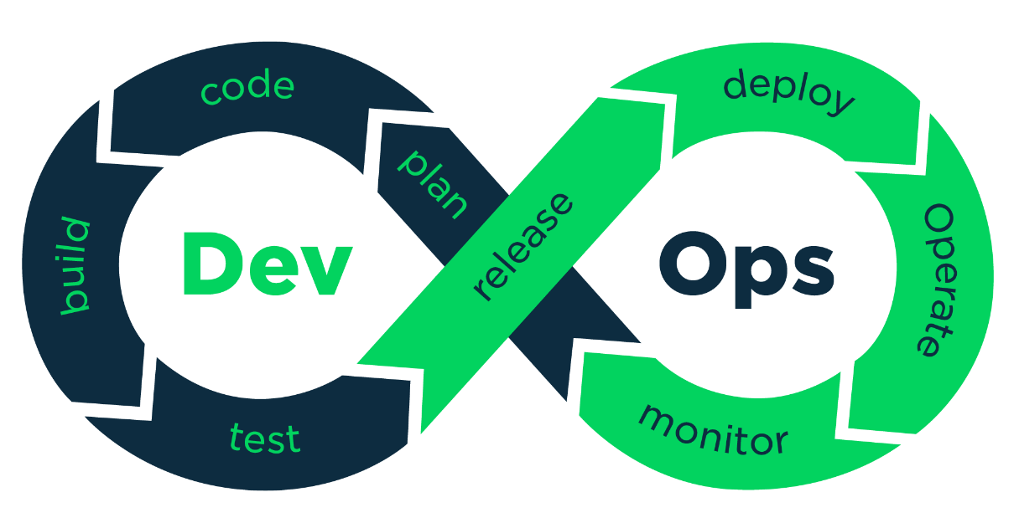

**DevOps principles** guide the integration of development and operations to achieve efficient and effective software delivery. Here are the key principles

* Culture of Collaboration and Communication:
  + Foster a culture where development, operations, and other stakeholders work together.
  + Promote open communication, shared goals, and a sense of shared responsibility.
* Automation:
  + Automate repetitive tasks to increase efficiency and reduce human error.
  + Use tools for automated testing, integration, deployment, and monitoring.
* Continuous Integration (CI):
  + Frequently merge code changes into a central repository.
  + Automatically test each integration to detect issues early.
* Continuous Delivery (CD):
  + Ensure that code is always in a deployable state.
  + Automate the release process to deliver software quickly and reliably.
* Infrastructure as Code (IaC):
  + Manage infrastructure using code and automation rather than manual processes.
  + Treat infrastructure configuration as software that can be versioned and tested.
* Monitoring and Logging:
  + Continuously monitor applications and infrastructure to gain insights into performance.
  + Use logs and metrics to identify and troubleshoot issues proactively.
* Lean and Agile Principles:
  + Apply lean principles to eliminate waste and improve processes.
  + Adopt agile methodologies for iterative development and continuous feedback.
* Measurement and Improvement:
  + Measure performance using key metrics to identify areas for improvement.
  + Continuously evaluate and refine processes to enhance efficiency and quality.
* Customer-Centric Action:
  + Focus on delivering value to customers quickly and efficiently.
  + Gather and act on customer feedback to improve the product continuously.
* Security:
  + Integrate security practices into the DevOps workflow.
  + Ensure that security is a shared responsibility among all team members (DevSecOps).

**DevOps Model**

Collaborative Culture:

Development and operations teams work together throughout the software development lifecycle (SDLC). Shared goals, open communication, and mutual accountability are emphasized.

Automation:

Automate as many processes as possible, including testing, integration, deployment, and monitoring.

Use tools and scripts to streamline workflows and reduce manual intervention.

Continuous Integration and Continuous Delivery (CI/CD):

Continuous Integration (CI): Developers frequently merge code changes into a shared repository. Each change is automatically tested to detect integration issues early.

Continuous Delivery (CD): Ensures that the code is always in a deployable state, allowing for frequent, reliable releases to production.

Infrastructure as Code (IaC):

Manage and provision infrastructure through code and automation tools.

Treat infrastructure configurations as code that can be versioned, tested, and reproduced.

Monitoring and Logging:

Continuously monitor applications and infrastructure for performance and availability.

Collect and analyze logs and metrics to gain insights and proactively address issues.

Feedback Loops:

Implement mechanisms for continuous feedback from development, operations, and end-users.

Use feedback to drive improvements in processes, tools, and product quality.

**DevOps Practices**

Version Control:

Use version control systems like Git to manage code changes.

Ensure all changes are tracked, and collaboration is facilitated through branching and merging.

Automated Testing:

Implement automated testing at various stages (unit, integration, system, and acceptance testing) to ensure code quality.

Use testing frameworks and tools to automate the execution and reporting of tests.

Continuous Integration:

Set up CI pipelines that automatically build and test code whenever changes are committed.

Use CI tools like Jenkins, Travis CI, or CircleCI to automate the process.

Continuous Delivery/Continuous Deployment:

Implement CD pipelines to automate the release process, ensuring that code is always in a deployable state.

Use tools like Jenkins, GitLab CI/CD, or Spinnaker for continuous delivery and deployment.

Configuration Management:

Use configuration management tools like Ansible, Puppet, or Chef to automate the setup and maintenance of infrastructure.

Ensure that configuration is consistent and reproducible across environments.

Infrastructure as Code (IaC):

Define and manage infrastructure using code and automation tools like Terraform, AWS CloudFormation, or Azure Resource Manager.

Enable version control, testing, and automation of infrastructure changes.

Monitoring and Logging:

Implement monitoring tools like Prometheus, Grafana, or Nagios to track system performance and health.

Use logging tools like ELK Stack (Elasticsearch, Logstash, Kibana), Splunk, or Fluentd to collect and analyze log data.

Containerization:

Use containerization technologies like Docker to package applications and their dependencies into containers.

Orchestrate containers using Kubernetes, OpenShift, or Docker Swarm for scalable and manageable deployments.

Security Integration (DevSecOps):

Integrate security practices into the DevOps workflow.

Use automated security testing, vulnerability scanning, and compliance checks as part of the CI/CD pipeline.

Collaboration and Communication Tools:

Use collaboration tools like Slack, Microsoft Teams, or Jira to enhance communication and project management.

Implement practices like daily stand-ups, retrospectives, and continuous feedback to foster a collaborative culture.

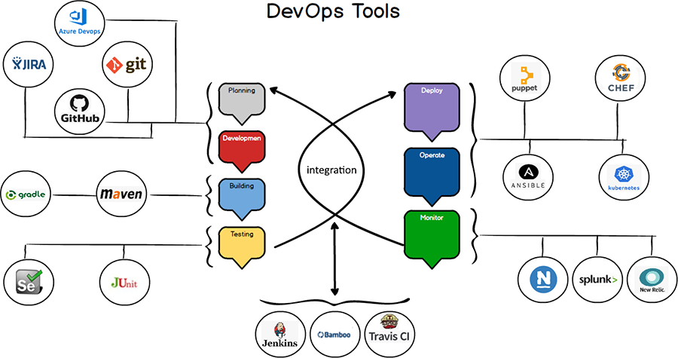

**DevOps Engineer** plays a crucial role in bridging the gap between development and operations teams to streamline and automate the processes involved in the software development lifecycle. Here are the key roles and responsibilities of a DevOps Engineer

**Roles**

Automation Expert:

Develop and maintain automation scripts and tools for building, testing, and deploying software.

Automate repetitive tasks to improve efficiency and reduce human error.

CI/CD Pipeline Developer:

Design, implement, and manage continuous integration and continuous delivery (CI/CD) pipelines.

Ensure that code changes are automatically tested and deployed to production environments.

Infrastructure Manager:

Use Infrastructure as Code (IaC) tools to manage and provision infrastructure.

Ensure that infrastructure is scalable, reliable, and secure.

Monitoring and Logging Specialist:

Set up and manage monitoring and logging systems to track application performance and system health.

Analyze logs and metrics to proactively identify and resolve issues.

Security Integrator:

Incorporate security best practices into the DevOps process (DevSecOps).

Implement automated security testing and vulnerability scanning.

Collaboration Facilitator:

Foster a culture of collaboration and communication between development, operations, and other stakeholders.

Ensure that all teams are aligned and working towards common goals.

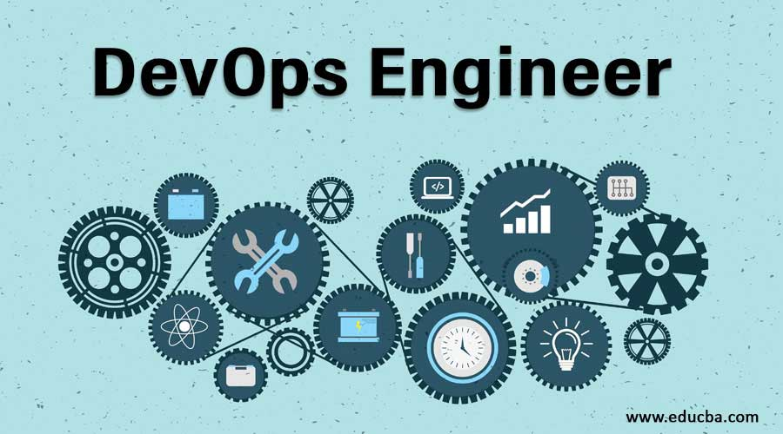

**Responsibilities**

Build and Maintain CI/CD Pipelines:

Develop and manage CI/CD pipelines to automate the build, test, and deployment processes.

Ensure that pipelines are efficient, reliable, and scalable.

Automate Infrastructure Management:

Use IaC tools like Terraform, Ansible, or CloudFormation to automate the provisioning and management of infrastructure.

Ensure that infrastructure is consistent across development, testing, and production environments.

Monitor Systems and Applications:

Set up monitoring tools like Prometheus, Grafana, or Nagios to track the performance and availability of systems and applications.

Implement alerting mechanisms to notify relevant teams of issues.

Manage Configuration and Deployment:

Use configuration management tools like Chef, Puppet, or Ansible to manage system configurations.

Ensure that deployments are automated, reliable, and repeatable.

Implement and Enforce Security Practices:

Integrate security practices into the DevOps workflow, ensuring that security is a shared responsibility.

Conduct regular security assessments and vulnerability scans.

Collaborate with Development and Operations Teams:

Work closely with developers to understand application requirements and dependencies.

Collaborate with operations teams to ensure that infrastructure meets performance and availability requirements.

Optimize Performance and Efficiency:

Continuously evaluate and optimize processes, tools, and workflows to improve efficiency and performance.

Identify bottlenecks and implement solutions to address them.

Troubleshoot and Resolve Issues:

Investigate and resolve issues related to CI/CD pipelines, infrastructure, and application performance.

Use logs, metrics, and monitoring data to diagnose and fix problems.

Document Processes and Procedures:

Maintain comprehensive documentation of CI/CD pipelines, automation scripts, and infrastructure configurations.

Ensure that documentation is up-to-date and accessible to relevant teams.

Stay Updated with Industry Trends:

Keep abreast of the latest DevOps tools, technologies, and best practices.

Continuously learn and adopt new approaches to improve the DevOps process.

